***Inspiration:*** Boosting nutrition through foods (adding calories, protein, nutrients through foods to meet residents/patient nutrition needs and prevent malnutrition) and product **focus of baking mixes and cereal** (vitamins/minerals delivered through cereal).

**Title: *Fueling Efficiency: Tackling Healthcare Foodservice Challenges Through Staff Training and Menu Optimization***

**Description:** Managing cost is an important part of a successful food service department. We have seen many challenges to maintaining budgets over the last few years, unfortunately few think about their staffing practices when they think of budget control. Poor hiring, onboarding and training can lead to significant cost for your department. In this session, you will learn how to identify areas of opportunity within your department to halt costly turnover. This webinar will also provide practical examples and menu solutions for **cross utilizing products across your menus**, which can help **reduce food waste and create labor efficiencies**.

**Objectives:**

* List key challenges facing healthcare food service operations today
* Describe ways staff training can increase efficiencies and create a productive workflow
* Identify ways to optimize menus to improve labor efficiency and reduce food waste while still meeting the preferences of patients and residents
* Apply menu optimization techniques and solutions to your foodservice operation

# A close-up of a dessert Description automatically generatedA plate of food with a fork Description automatically generatedA bowl of dessert with whipped cream and a cup of coffee Description automatically generatedMix Recipes:

[Easy-deep-dish-cobbler](https://www.generalmillsfoodservice.com/recipes/easy-deep-dish-cobbler/2a74adda-da28-435f-8a92-0eafeac388a9)

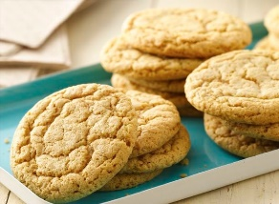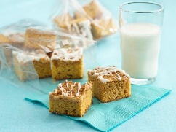[Cranberry-apple-cobbler](https://www.generalmillsfoodservice.com/recipes/new-england-apple-cobbler/e5039c68-4884-4384-9df4-1c0a58498635)

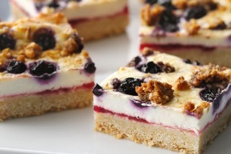[Very-berry-oatmeal-bars-soft-and-bite-sized-level-6](https://www.generalmillsfoodservice.com/recipes/raspberry-oatmeal-bars-soft-and-bite-sized-level-6/87114168-6029-4944-9b87-cb1a2bc8eb28)

[Parfait-bar (Holiday Cheesecake Bites)](https://www.generalmillsfoodservice.com/recipes/parfait-bar/c5d0f6e9-83ff-4a49-91ee-c5a8ffb76275)

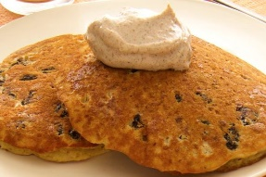[Pumpkin-spice-blondies](https://www.generalmillsfoodservice.com/recipes/pumpkin-spice-blondie/c9b88499-863e-4ba7-a602-7ac0f64ae655)

[Pumpkin-spice-shortbread-cookies](https://www.generalmillsfoodservice.com/recipes/pumpkin-spice-cookies/19b73da5-4bb7-4ea7-aa7c-8e406e4f5f0d)

[Shortbread-tea-cookies](https://www.generalmillsfoodservice.com/recipes/shortbread-tea-cookies/d74f942a-e05c-4f2b-9cf1-667c315bd7cb)

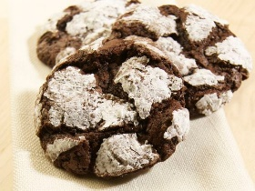[Oatmeal-raisin-pancakes-with-cinnamon-sour-cream](https://www.generalmillsfoodservice.com/recipes/oatmeal-raisin-pancakes-with-cinnamon-sour-cream/4e5fdd25-b0cc-4352-9e15-e87a50ccac0e)

[Cranberry-almond-crunch-granola-snack-mix](https://www.generalmillsfoodservice.com/recipes/cranberry-almond-crunch-granola/85c6f7c5-4f48-4f7e-ae66-538848a82ec4)

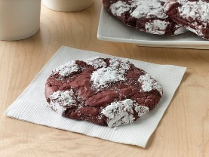[Fudge-brownie-crinkle-cookies](https://www.generalmillsfoodservice.com/recipes/fudge-brownie-crinkle-cookies/911473c9-0440-49c8-b194-54759519370e)

[Red Velvet Crinkle Cookies | General Mills Foodservice](https://www.generalmillsfoodservice.com/recipes/red-velvet-crinkle-cookies/817106d6-909c-4128-92d5-6d5f19d1b565)